**TRIBHUVAN UNIVERSITY**

**INSTITUTE OF ENGINEERING**

**Lab Sheet #9**

**PURWANCHAL CAMPUS**

DHARAN-8

**Submitted by:** **Submitted to:**

Name: **Arbind Kumar Mehta** Department of

Roll No: **PUR075BCT017** Electronics & Computer

Faculty: BCT Engineering

Group: I/I ‘A’

Date: ….......................... Checked by: ……………………….

**Title:**

Write a program to read RollNo, Name, Address, Age & marks in physics, C, math in 1st semester of three students in BCT and display the student details with average marks achieved.

**Code:**

#include <stdio.h>

#include <stdlib.h>

#include <string.h>

struct student

{

char nam[30],rem[10];

int rol,ran,mar;

float per;

}s[100];

void read(struct student s[],int sn)

{

int i,j;

for(i=0;i<sn;i++)

{

printf("Enter the name of student(Max.30 char.):\n");

scanf(" %[^\n]s",s[i].nam);

printf("Enter the roll number of %s:\n",s[i].nam);

scanf("%d",&s[i].rol);

printf("Enter the marks of %s:\n",s[i].nam);

scanf("%d",&s[i].mar);

}

printf("Record has been created sucessfully!!!\n\n");

}

void display(struct student s[],int sn)

{

int i,j,temp=0;

//for rank

for(i=0;i<sn;i++)

{

s[i].ran=(i+1);

}

for(i=0;i<sn-1;i++)

{

for(j=i+1;j<sn;j++)

{

if(s[i].mar<=s[j].mar)

{

temp=s[i].ran;

s[i].ran=s[j].ran;

s[j].ran=temp;

}

}

}

printf("The information of student according to roll number is:\n");

printf("S.No.\tRoll Number\tName\t\t\tMarks\t\tPercent(%%)\t\tRank\t\tRemark\n");

printf("*****************************************************************************************************************\n");

for(i=0;i<sn;i++)

{

s[i].per=((float)s[i].mar/500)*100.0;

if(s[i].per<40.00)

strcpy(s[i].rem,"Fail");

else

strcpy(s[i].rem,"Pass");

printf("%d\t%d\t\t%s\t\t%d\t\t%.3f\t\t\t%d\t\t%s\n",(i+1),s[i].rol, s[i].nam, s[i].mar, s[i].per, s[i].ran, s[i].rem);

}

}

int main()

{

int ch1,ch2,ch3,sn,temp1=0,i;

while(1)

{

printf("Please make a choice:\n\nPress '1' to make a new record.\nPress '2' to edit record.\nPress '3' to view stored record.\nPress '4' to exit.\n");

scanf("%d",&ch1);

switch(ch1)

{

case 1 :

{

printf("Enter the total number of student(Max.100):\n");

scanf("%d",&sn);

read(s,sn);

break;

}

case 2 :

{

printf("Press '1' to edit name of student.\nPress '2' to edit roll number of student.\nPress '3' to edit marks of student\nPress '4' to go to main menu.\n");

scanf("%d",&ch2);

printf("Enter the roll number of student to be edited.");

scanf("%d",&ch3);

for(i=0;i<sn;i++)

{

if(s[i].rol==ch3)

temp1=i;

}

switch(ch2)

{

case 1 :

{

printf("The name of student is %s\nEnter new name:",s[temp1].nam);

scanf(" %[^\n]s",&s[temp1].nam);

printf("Changed sucessfully!!!\n\n");

break;

}

case 2 :

{

printf("The roll number of student is %d and name is %s\nEnter new roll number:",s[temp1].rol, s[temp1].nam);

scanf("%d",&s[temp1].rol);

printf("Changed sucessfully!!!\n\n");

break;

}

case 3 :

{

printf("The name of student is %s and mark(s) is %d\nEnter new mark(s):",s[temp1].nam, s[temp1].mar);

scanf("%d",&s[temp1].mar);

printf("Changed sucessfully!!!\n\n");

break;

}

case 4 :

{

break;

}

default:

{

printf("Invalid choice!!!\n");

break;

}

} break;

case 3 :

{

display(s,sn);

getch();

break;

}

case 4 :

{

exit(0);

}

default:

{

printf("Invalid choice!!!\n");

getch();

break;

}

}

}

}

return 0;

}

**Output (Compilation, Debugging and Testing):**

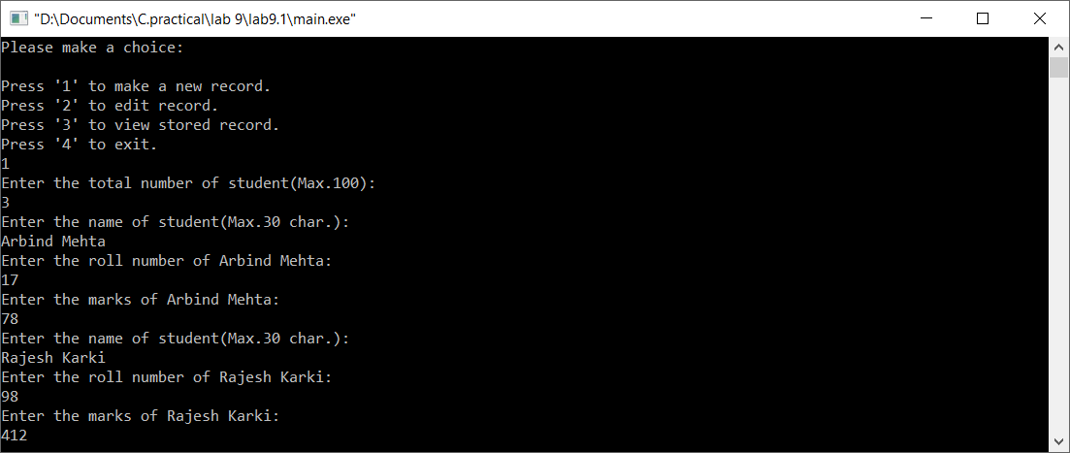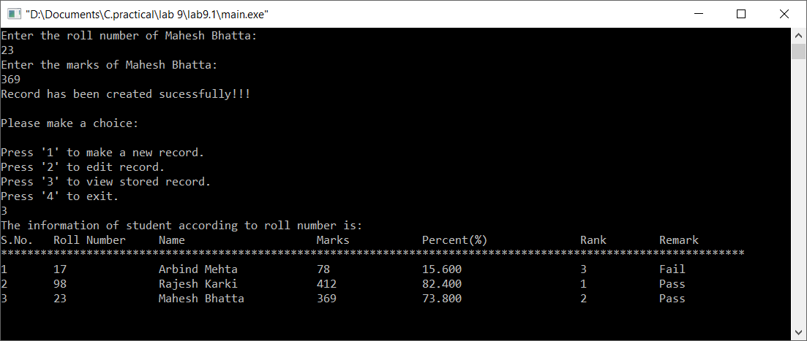

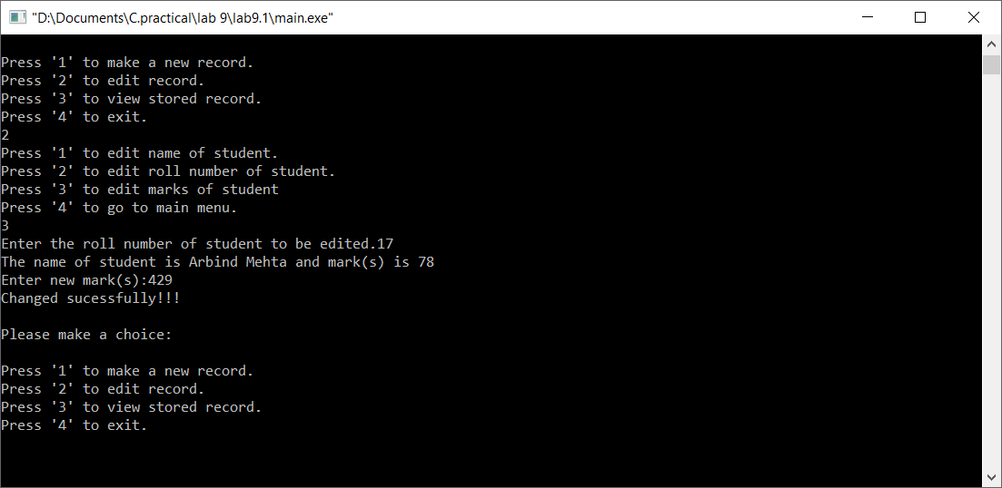

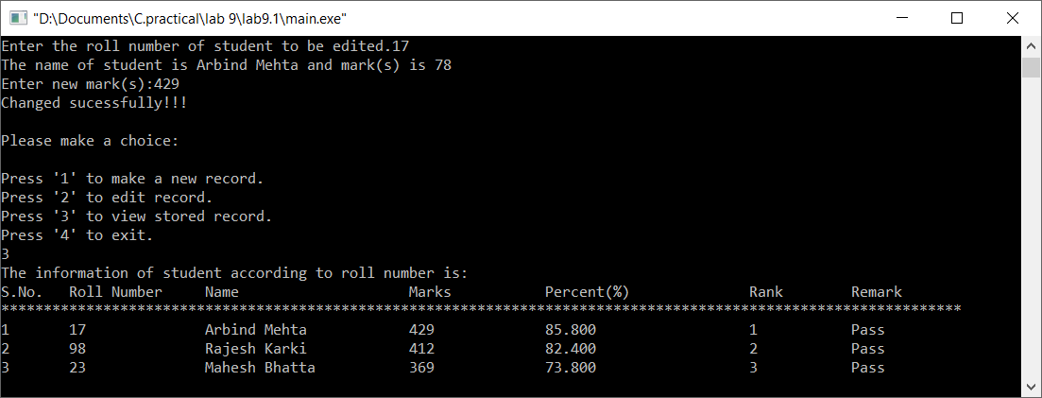

**Title:**

Create a structure named company which has name, address, phone and noOfEmployee as member variables. Read name of company, its address, phone and noOfEmployee. Finally display these members’ value.

**Code:**

#include <stdio.h>

#include <stdlib.h>

#include <string.h>

struct company

{

char nam[30],rem[20],add[50],ph[10];

int empno;

}s[100];

void read(struct company s[],int sn)

{

int i;

char c[20];

for(i=0;i<sn;i++)

{

printf("Enter the name of company(Max.30 char.):\n");

scanf(" %[^\n]s",s[i].nam);

printf("Enter the address of %s:\n",s[i].nam);

scanf("%s",s[i].add);

printf("Enter the employee number number of %s:\n",s[i].nam);

scanf("%d",&s[i].empno);

printf("Enter the phone number of %s:\n",s[i].nam);

scanf("%s",&s[i].ph);

fflush(stdin);

printf("Enter remark (if any):\n");

gets(c);

if(c!="\n")

{

strcpy(s[i].rem,c);;

}

}

printf("\nRecord has been created sucessfully!!!\n\n");

getch();

}

void display(struct company s[],int sn)

{

int i;

printf("The information of company is:\n");

printf("S.No.\tName\t\tAddress\t\tPhone Number\t\tNumber of Employee\t\tRemark\n");

printf("*****************************************************************************************************************\n");

for(i=0;i<sn;i++)

{

printf("%d\t%s\t\t%s\t\t%s\t\t%d\t\t\t\t%s\n",(i+1),s[i].nam, s[i].add, s[i].ph, s[i].empno, s[i].rem);

}

}

int main()

{

int ch1,sn;

while(1)

{

printf("Please make a choice:\n\nPress '1' to make a new record.\nPress '2' to view stored record.\nPress '3' to exit.\n");

scanf("%d",&ch1);

switch(ch1)

{

case 1 :

{

printf("Enter the total number of company(Max.100):\n");

scanf("%d",&sn);

read(s,sn);

break;

}

case 2 :

{

display(s,sn);

getch();

break;

}

case 3 :

{

exit(0);

}

default:

{

printf("Invalid choice!!!\n");

getch();

break;

}

}

}

return 0;

}

**Output (Compilation, Debugging and Testing)**

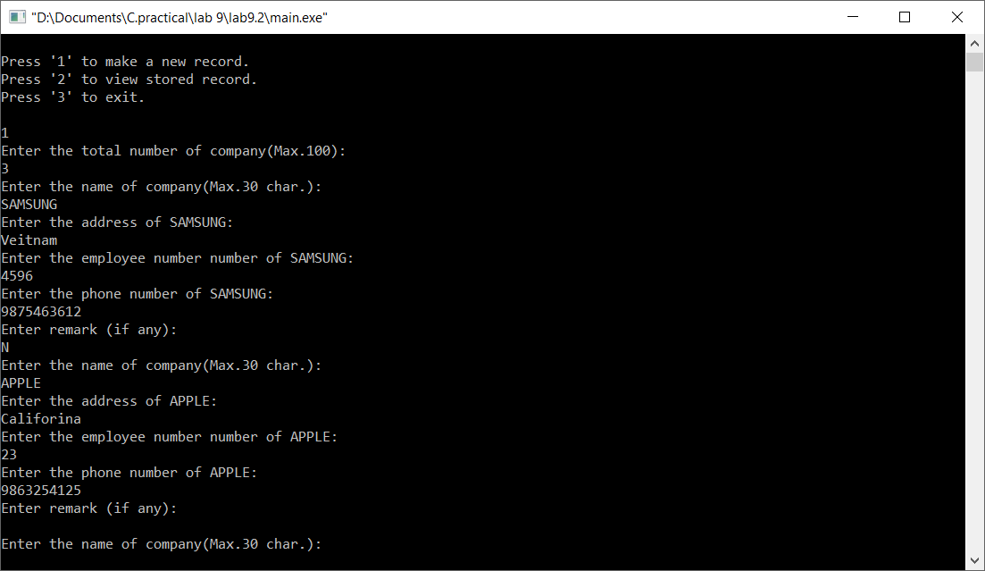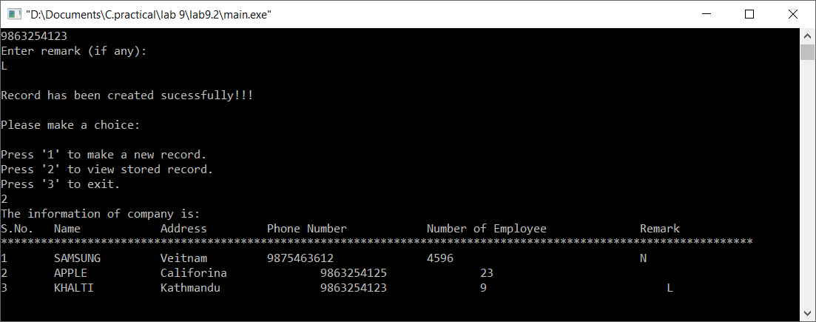

**Title:**

Write a program to enter to Cartesian coordinate points and display the distance between them.

**Code:**

#include <stdio.h>

#include <stdlib.h>

#include<math.h>

int main()

{

float x1,x2,y1,y2,d;

printf("Please enter (x1,y1) and (x2,y2) respectively:\n");

scanf("%f%f%f%f",&x1,&y1,&x2,&y2);

d=sqrt(pow(x2-x1,2)+pow(y2-y1,2));

printf("Distance between (%.1f,%.1f) and (%.1f,%.1f) is: %.2f units.",x1,y1,x2,y2,d);

getch();

return 0;

}

**Output (Compilation, Debugging and Testing):**

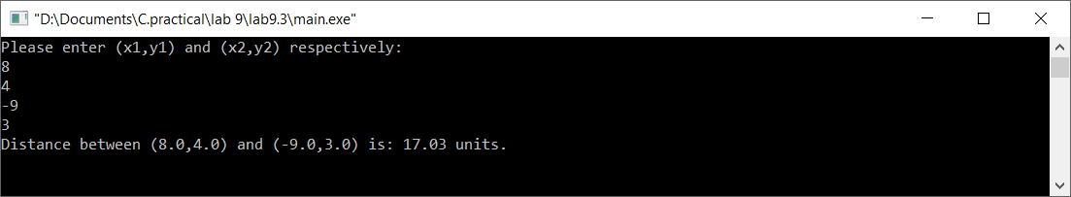

**Title:**

Write a function which accepts structure as argument and returns structure to the calling program.

**Code:**

#include <stdio.h>

#include <stdlib.h>

typedef struct info

{

char nam[20];

int ag;

}info;

info read(info i)

{

info d;

printf("Enter your name:\n");

gets(i.nam);

printf("Enter your age:\n");

scanf("%d",&i.ag);

return i;

};

void display(info j)

{

printf("Your name is: %s\nYour age is: %d",j.nam,j.ag);

}

int main()

{

info s1;

display(read(s1));

return 0;

}

**Output (Compilation, Debugging and Testing):**

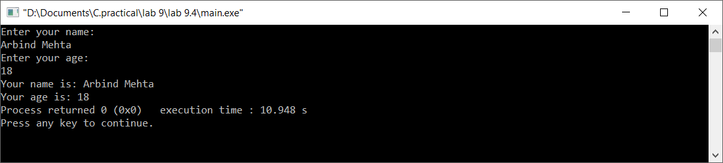

**Title:**

Pass the structures defined in Question 1 into a function and read the structure member and display the values from the function (use structure pointer).

**Code:**

#include <stdio.h>

#include <stdlib.h>

#include <string.h>

struct company

{

char nam[30],rem[20],add[50],ph[10];

int empno;

}*e;

void read(struct company *s)

{

char c;

printf("Enter the name of company(Max.30 char.):\n");

scanf(" %[^\n]s",s->nam);

printf("Enter the address of %s:\n",s->nam);

scanf("%s",s->add);

printf("Enter the employee number number of %s:\n",s->nam);

scanf("%d",&s->empno);

printf("Enter the phone number of %s:\n",s->nam);

scanf("%s",&s->ph);

printf("Enter remark (if any):\n");

c=getch();

while(c!="\n")

{

gets(s->rem);

break;

}

printf("\nRecord has been created sucessfully!!!\n\n");

getch();

}

void display(struct company *s)

{

printf("The information of company is:\n");

printf(" Name\t\tAddress\t\tPhone Number\t\tNumber of Employee\t\tRemark\n");

printf("*****************************************************************************************************************\n");

printf(" %s\t%s\t\t%s\t\t%d\t\t\t\t%s\n",s->nam, s->add, s->ph, s->empno, s->rem);

}

int main()

{

read(&e);

display(&e);

}

**Output (Compilation, Debugging and Testing):**

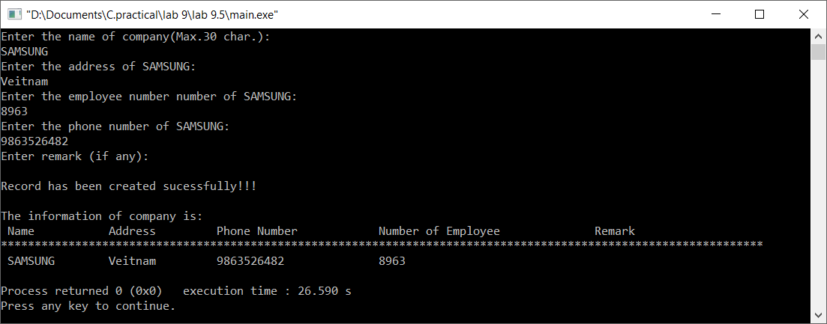

**Title:**

Define a structure “complex” (typedef) to read two complex numbers and perform addition, subtraction of these two complex numbers and display the result.

**Code:**

#include <stdio.h>

#include <stdlib.h>

typedef struct com

{

float rel[2];

float img[2];

}com;

void read(com n)

{

int i;

float sumr=0;

float sumi=0;

float diffr=0;

float diffi=0;

printf("Enter (x1,j1i) and (x2,j2i):\n");

for(i=0;i<2;i++)

{

scanf("%f%f",&n.rel[i],&n.img[i]);

sumr+=n.rel[i];

sumi+=n.img[i];

}

i=0;

diffr=n.rel[i]-n.rel[i+1];

diffi=n.img[i]-n.img[i+1];

printf("The sum is: (%.1f,%.1fi) and difference is: (%.1f,%.1fi)",sumr,sumi,diffr,diffi);

getch();

}

int main()

{

com s;

read(s);

return 0;

}

**Output (Compilation, Debugging and Testing):**

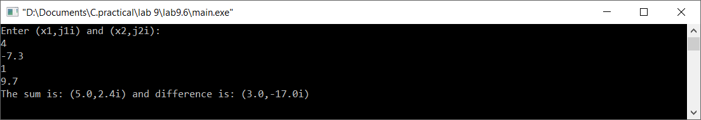

**Title:**

Write a program to show programming examples with union and enumerations.

**Code:**

#include <stdio.h>

#include <stdlib.h>

#include<string.h>

typedef union student //using union

{

char nam[50];

int rol,mar;

}st;

int main()

{

st s1;

enum students{Arbind=1, Anil, Zagir, Manish=10, Rahul, Prasant}; //declaring enum

strcpy(s1.nam,"Arbind Kumar Mehta"); //assigment operation only one at a time

printf("Student name is: %s\n",s1.nam);

s1.rol=017;

printf("Roll number of student is: %d\n",s1.rol);

s1.mar=213;

printf("Obtained mark(s) is: %d\n",s1.mar);

getch();

printf("The index of Arbind is\t%d\n",Arbind);

printf("The index of Anil is\t%d\n",Anil);

printf("The index of Zagir is\t%d\n",Zagir);

printf("The index of Manish is\t%d\n",Manish);

printf("The index of Rahul is\t%d\n",Rahul);

printf("The index of Prasant is\t%d\n",Prasant);

getch();

return 0;

}

**Output (Compilation, Debugging and Testing):**



